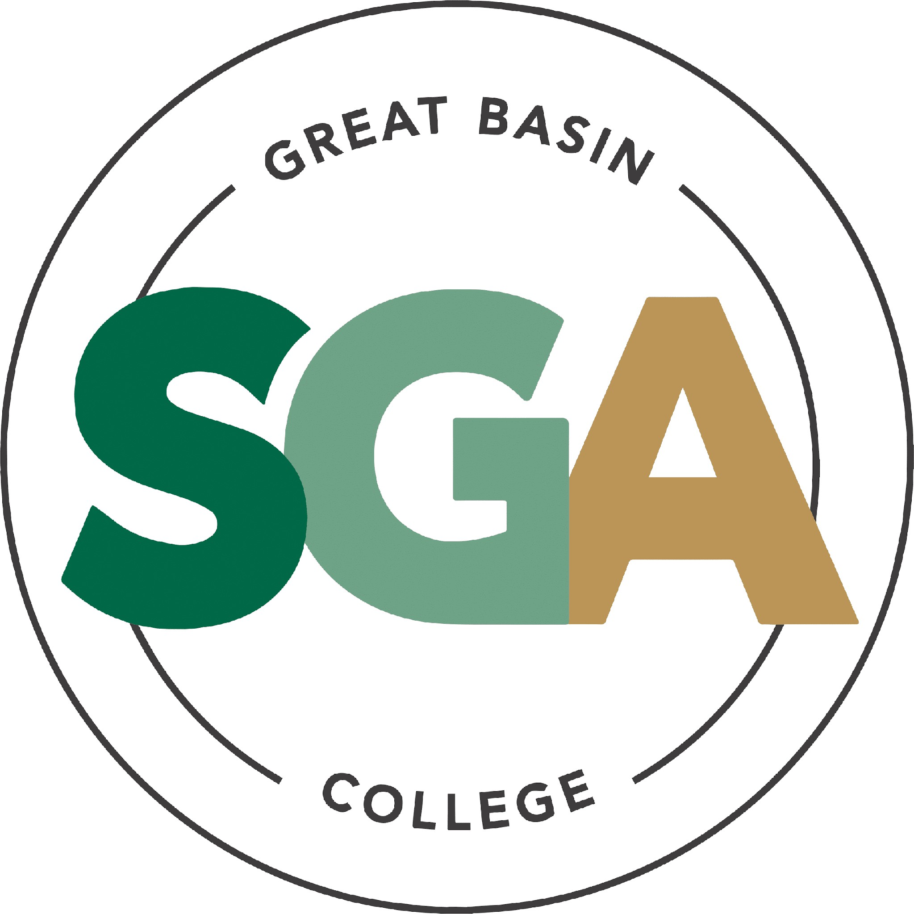

STUDENT GOVERNMENT ASSOCIATION (SGA)

MINUTES SEPTEMBER 22, 2026
3:00 PM
MEETING CALLED TO ORDER AT 3:00 PM
VIDEO OR TELEPHONE CONFERENCE CONNECTION FROM THE MEETING SITE TO: 1500 COLLEGE PARKWAY; SGA OFFICE, LEONARD CENTER FOR STUDENT LIFE, GREAT BASIN COLLEGE CAMPUS, ELKO NV 89801

A VIDEO CONFERENCE CONNECTION WILL BE MADE FROM THE MEETING SITE TO ALL OTHER CAMPUS LOCATIONS.

THE PUBLIC MAY ATTEND THE MEETING AND PROVIDE PUBLIC COMMENT AT THIS SITE. PUBLIC COMMENT MAY ALSO BE SUBMITTED VIA ONLINE BY EMAILING SGA@GBCNV.EDU. COMMENTS MUST BE RECEIVED BY 5 PM PST THE DAY PRIOR TO THE MEETING. MEMBERS OF THE PUBLIC WISHING TO VIEW OR ATTEND THE MEETING MAY DO SO VIA ZOOM AT:

https://gbcnv-edu.zoom.us/j/84298011629?pwd=u7cz48zIwBHMP2dBEHkFAQ9r3DEMQR.1

EXECUTIVE MEMBERS:

STORM RAINE, PRESIDENT PRESENT JULIA STOKES, VICE PRESIDENT PRESENT
MUHAMMED/DIVINE, INTERIM - SECRETARY PRESENT SENATORS:

GUESTS:
MUHAMMED SALIKHOV, ELKO PRESENT JULIAN SOSA, ELKO PRESENT
DIVINE JACOBSON, ELKO PRESENT
DAVID BERNADINO-LOPEZ, ELKO PRESENT CALVIN COWAN, PAHRUMP PRESENT
LIZ NASH, ELY PRESENT
CATHERINE COLE, ONLINE PRESENT
MATT ASCHENBRENER - INTERIM STUDENT ADVOCATE, VICE PRESIDENT OF STUDENT AFFAIRS
AMBER DONELLI – PRESIDENT OF GBC
NIKKI TINGEY – ADMINISTRIVE ASSISTANT II
CAMILA CONTRERAS - STUDENT, WINNEMUCCA SENATOR CANDIDATE SOFIA MAYORGA - STUDENT, WINNEMUCCA & ONLINE SENATOR CANDIDATE JOCKSSON CONTRERAS - STUDENT, ELKO SENATOR CANDIDATE
PAYTON - STUDENT, WINNEMUCCA SENATOR CANDIDATE
SHAKIRA CHESEBRO - ADMINISTRATIVE ASSISTANT III

LIZABETH DIAZ - WINNEMUCCA SNO REPRESENTATIVE
DAPHANE TAYLOR - STUDENT, ELKO SENATOR CANDIDATE ERIKA WRIGHT- STUDENT, ELKO SENATOR CANADIDATE JAVIER TOVAR - STUDENT, ELKO SENATOR CANADIDATE DANIELLE KIRKMAN – PUBLIC
SADIE CRABS – FOUNDATION ELKO CAMPUS
MORGAN JOHNSON – ELKO STUDENT
CARLY GEORGE – ELKO STUDENT

NOTE: Below is an agenda of all items scheduled to be considered. Notification is hereby provided that items on the agenda may be taken out of the order presented, two or more agenda items may be combined for consideration, and an agenda item may be removed from the agenda or discussion relating to an item on the agenda may be delayed at any time.
The agenda and any supporting material, including materials submitted after the posting of this agenda but before the meeting, may be accessed on the Internet by visiting the SGA page of the GBC website: Great Basin College: Student Life - Meetings.
In accordance with NRS241.020(6), supporting materials that are submitted to the Student Government Association (SGA) will be made available in advance of the meeting. Reasonable efforts will be made to assist and accommodate physically disabled persons attending the meeting. Please call the Office for Students with Disabilities (775) 327-2336 in advance so that arrangements may be made.

- ROLL CALL

  - Roll call of members and any persons serving as a proxy for a member will be taken.

- PUBLIC COMMENT INFORMATION ONLY

Public comment will be taken during this agenda item. No action may be taken on a matter raised under this item until the matter is included on an agenda as an item on which action may be taken. Comments will be limited to two minutes per person. Persons making comment will be asked to begin by stating their name for the record and to spell their last name. The SGA President may elect to allow additional public comment on a specific agenda item when that agenda item is being considered.

Pursuant to NRS 241.023, members of the public may also participate in the meeting by submitting written public comment messages via email to james.kendall@gbcnv.edu. Written statements received by 4:30 p.m. on THURSDAY, SEPTEMBER 17th, 2026, will be distributed to SGA members and included in the permanent meeting record and names of those who provide public comment via email will be announced at the meeting, however messages will no longer be read into the record. Members of the public may attend the meeting and provide public comment.

In accordance with Attorney General Opinion No. 00-047 (April 27, 2001), as restated in the Attorney General’s Open Meeting Law Manual, the President may prohibit comment if the content of that comment is a topic that is not relevant to, or within the authority of, the SGA, or if the content is willfully disruptive of the meeting by being irrelevant, repetitious, slanderous, offensive, inflammatory, irrational or amounting to personal attacks or interfering with the rights of other speakers.

- APPROVAL OF AGENDA POSSIBLE ACTION
A Request is made for approval of the GBC SGA Agenda for the meeting on 9/22/26.
SENATOR

- APPROVAL OF PREVIOUS MINUTES POSSIBLE ACTION
A Request is made for approval of the GBC SGA Minutes for the meeting on 9/15/2026.

SENATOR SOSA MOTIONS TO APPROVE, SENATOR SALIKHOV SECONDS THAT MOTION. MOTION PASSES UNANIMOUSLY

- PRESIDENT’S REPORT INFORMATION ONLY

SGA PRESIDENT RAINE will discuss current SGA events and activities as SGA President.

PRESIDENT RAINE: HOPES EVERYONE IS HAVING A GREAT TIME, HE ALSO HOPES EVERYONE HAD FUN WITH THE ELECTIONS. EVERYONE THAT IS SWORN IN WILL BE

- VICE PRESIDENT’S REPORT INFORMATION ONLY

SGA VICE PRESIDENT STOKES will discuss current SGA events and activities as SGA Vice President.

VICE PRESIDENT STOKES REPORTED THAT SHE IS STILL WORKING ON THE BEATS AND BITES EVENT WITH PRESIDENT RAINE.

- STUDENT ADVOCATE’S REPORT INFORMATION ONLY

INTERIM STUDENT ADVOCATE will discuss current SGA events and activities as interim student advocate.

MATT ASCHENBRENER REPORTED THAT HE IS IN THE PROCESS OF GETTING THE APPROVAL FOR THE RAISE ON HOUSING.

- SENATOR REPORTS INFORMATION ONLY
SENATOR COWAN: WORKING ON INITIATIVES WITH THE PAHRUMP CAMPUS, SINCE CHRISTOPHER SALUTE IS LEAVING H
SENATOR COLE: REPORTED THAT SHE IS WORKING ON THE ZOOM ZOO, AND HOPES TO HAVE AN INVOICE BY NEXT WEEK TO HAVE IT READY BEFORE FINALS WEEK FOR A STRESS RELIEVER.
SENATOR NASH: REPORTED THAT THE ELY BEATS AND BITES WILL BE HAPPNEING THIS WEEK AND WOULD LIKE TO PROMOTE THE ZOOM TO GET ONLINE STUDENTS TO ENGAGE. SHE HAS GAMES SET UP WITH KAHOOT AND UNO.
SENATOR JACOBSON: NOTHING TO REPORT
SENATOR SOSA: WISHED EVERYONE LUCK IN THE ELECTIONS
SENATOR SALIKHOV: WISHED EVERYONE LUCK IN THE ELECTIONS.
SENATOR BERNARDINO: NOTHING TO REPORT AT THIS TIME
- COMMITTEE REPORTS INFORMATION ONLY
Chairs of each Committee (Beats and Bites & Constitution and Amendments) will discuss the progress of their committees.
BEATS AND BITES WITH SENATOR NASH:
CONSTITUTION AND AMENDMENTS WITH SENATOR SOSA: REPORTED THAT THEY WERE FIGURING OUT WHO WAS A PART OF THE COMMITTEE DURING THEIR LAST WEEK MEETING AS WELL AS WORKING ON FIGURING OUT THEIR DATES AND TIMES FOR THEIR MEETINGS.
- UNFINISHED BUSINESS INFORMATION ONLY
- RAD Student Organization Recognition
- Carly George will be presenting on this item.
CARLY REPORTED THAT THEY HAD THEIR FIRST MEETING LAST WEEK AND HAD ABOUT 40 STUDENTS SHOW UP, AS THE PRESIDENT SHE WOULD LIKE TO TAKE STUDNETS TO VEGAS FOR A RADIO LOGIC CONFERENCE.
SENATOR SOSA MOTIONS TO APPROVE THE RECOGNITION OF THE RAD GROUP, SENATOR SALIKHOV SECONDS THAT MOTION. MOTION PASSES UNANIMOUSLY
- D&D Club Recognition
- Storm Raine will be presenting on this item.
SENATOR NASH ASKED IF THIS COULD BE POSTED ON CANVAS AS WELL AS HOST A ZOOM VERSION OF THIS SO STUDENTS FROM OTHER CAMPUSES CAN ATTEND.
SENATOR SOSA MOTIONS TO APPROVE THE D&D CLUB, SENATOR SALIKHOV SECONDS THE MOTION. MOTION PASSES UNANIMOUSLY
- SGA Elections
- SGA will find a resolution to issues that arose with the fall election.
VICE PRESIDENT: JULIAN SOSA
SECRETARY: MUHAMMED SALIKHOV
ELKO SENATOR: JULIA STOKES
ELKO SENATOR: JAVIER TOVAR
ELKO SENATOR: JOCKSSON CONTRERAS
ELKO SENATOR: ERICA WRIGHT
ELKO SENATOR: DAPHANE TAYLOR
ELKO SENATOR: KASIDY WAKLEY
ONLINE SENATOR: CATHERINE COLE
ONLINE SENATOR: SOFIA MAYORGA
ONLINE SENATOR: DYLAN MARTIN
WINNEMUCCA SENATOR: PAYTON MINYARD
WINNEMUCCA SENATOR: CAMILA CONTRERAS
ELY SENATOR: LIZ NASH

- PRESIDENT DONNELI ADDRESSING SGA INFORMATION ONLY

SHE REPORTED THAT THEIR WAS A LOT GOING ON AT GBC AND THAT WE HAVE 22% INCREASE IN STUDENTS FOR THIS SEMESTER ALONE. AS WELL AS SHE IS TRYING TO MAKE SURE WE HAVE ENOUGH STAFF AND ADVISORS FOR THIS INCREASE. SHE SAID SHE IS ALSO WORKING ON A HELP DESK THAT IS AI DRIVEN AND WILL HELP STUDENTS WITH THEIR ACCOUNTS AFTER HOURS AND MAKING A SYSTEM THAT CAN UPDATE EVERYONE THROUGH TEXT MESSAGE. SHE TOOK STUDENTS WITH HER ON A LEGISLATURE TRIP THAT GAVE A SPEECH ABOUT BEING A STUDENT IN RURAL NEVADA. SHE ALSO SAID THAT DORMS IN HOUSING WILL BE GETTING A NEW ROOF FROM A FUNDING.

CALVIN COWAN: ASKED ABOUT GETTING APPROVAL ON FURNITURE AS WELL AS ASKED ABOUT LAND ACKNOWLEDGMENT STATEMENT HE ASKED ABOUT GETTING IT APPROVED.

DONELLI: STATED THAT IT WAS SUBMITTED TO FACULTY AS AN INFORMATIONAL ITEM BUT IT WILL BE GOING UP IN THE RANKINGS FOR APPROVAL. THE BUDGET IN PAHRUMP FOR FURNITURE HAD TO GET CLOSED OUT DUE TO WAIT TIMES.

SOSA: APPRECIATES DONNELIS WORK ON THE LAND ACKNOWLEDGMENT. WOULD LIKE FOR SOMEONE ELSE TO APPROACH THIS RATHER THEN A STUDENT OR A NATIVE AMERICAN PERSON.

- UPCOMING ITEMS

- Housing Income and Price Changes
  - Matt Aschenbrener will be presenting this item.
  - Housing could be increasing its prices by 10%, the revenue gained from this increase will be used for possible renovations. POSSIBLE ACTION
SENATOR SOSA ASKED ABOUT WHAT THE BUDGET AND INCOMING AND EXPENSES WERE LOOKING LIKE.
PRESIDENT DONNELI STATED THAT WE HAD ABOUT $350,00 THOUSAND IN LEFT OVER FUNDS AND $150,000 OF THAT WENT TO RA’S, MAINTANANCE, AND UPKEEPING REMODELING.

- Event Committee Formation
  - Senator Cowan has proposed the formation of an events committee POSSIBLE ACTION
ITEM WAS TABLED TO NEXT MEETING

- Survey Committee Formation
  - Senator Nash has proposed the formation of an events committee. POSSIBLE ACTION

ITEM WAS TABLED TO NEXT MEETING

- Student Organization Committee Formation
  - President Raine has proposed the formation of an events committee.

ITEM WAS TABLED TO NEXT MEETING

- Pumpkin Decorating Contest Prizes
  - Senator Nash is requesting funding from the Ely SGA Account. She is requesting $200
for Prizes for a Pumpkin Decorating Contest. The prizes will include cups, bags,
chocolate, banners, and keychains. The event has been funded by SGA before and will be
held on 10/29/26.

SENATOR SALIKHOV MOTIONS TO APPROVE THE CONTEST. SENATOR COLE SECONDS THAT MOTION. MOTION IS PASSED UNANIMOUSLY

- Pickleball Funding Request

  - Javier Tovar would like to request funding for the Pickleball Club. He is requesting $950
from the Pickleball Club account. The money will be used to take the pickleball
executives, (President, Vice President, Secretary, Treasurer) and Advisor to a pickleball
open in Las Vegas. The Pickleball Club wishes to learn how to host a competitive
pickleball tournament through this event.
  - Price Breakdown: Tickets $366.90, Hotel (3 rooms) $550. The full total is $950.

VP SOSA MOTIONED TO REMOVE THIS ITEM INDEFINETLY, SENATOR JACOBSON
SECONDED THAT MOTION. MOTION PASSED UNANIMOUSLY

- SGA Funding Request

  - Nikki Tingey and Janna Nettleton are requesting approval to purchase supplies to
maintain the coffee cart at Winnemucca Center. The coffee cart provides refreshments for
students. 50+ students have used the coffee cart and the coffee cart has received SGA
funding before. They are requesting $500.

SENATOR CAMILA CONTRERAS ELABORATED ON THIS. SENATOR JACOBSON MOTIONED TO APPROVE THE $500, SENATOR COLE SECONDED THAT MOTION. MOTION IS PASSED UNANINMOUSLY.

SENATOR COLE MOTIONED TO TABLE LEFT OVER ITEMS, SENATOR SALIKHOV SECONDED THAT MOTION. MOTION WAS PASSED UNANIMOUSLY.

- NEW BUSINESS INFORMATION ONLY
Items for consideration at future meetings may be suggested. Any discussion of an item under “New Business” is limited to description and clarification of the subject matter of the item, which may include the reasons for the request, and no substantive discussion may occur at this meeting on new business items in accordance with the Nevada Open Meeting Law (NRS 241.010 et seq.).
NO NEW BUSINESS
- PUBLIC COMMENT INFORMATION ONLY

Public comment will be taken during this agenda item. No action may be taken on a matter raised under this item until the matter is included on an agenda as an item on which action may be taken. Comments will be limited to two minutes per person. Persons making comments will be asked to begin by stating

their name for the record and to spell their last name. The SGA President may elect to allow additional public comment on a specific agenda item when that agenda item is being considered.

Pursuant to NRS 241.023, members of the public may also participate in the meeting by submitting written public comment messages via email to james.kendall@gbcnv.edu. Written statements received by 4:30 p.m. on THURSDAY, SEPTEMBER 10th, 2026, will be distributed to SGA members and included in the permanent meeting record, and names of those who provide public comment via email will be announced at the meeting, messages will no longer be read into the record. Members of the public may attend the meeting and provide public comment.

In accordance with Attorney General Opinion No. 00-047 (April 27, 2001), as restated in the Attorney General’s Open Meeting Law Manual, the President may prohibit comment if the content of that comment is a topic that is not relevant to, or within the authority of, the SGA, or if the content is willfully disruptive of the meeting by being irrelevant, repetitious, slanderous, offensive, inflammatory, irrational or amounting to personal attacks or interfering with the rights of other speakers.
Posted in accordance with Nevada Open Meeting Law (NRS Ch. 241), at the following locations:
GBC, Berg Hall, 1500 College Parkway, Elko, NV 89801 Nevada Public Notice Website - https://notice.nv.gov
GBC SGA Website - Great Basin College: Student Life - Meetings.

- ADJOURNMENT INFORMATION ONLY

SECRETARY SALIKHOV MOTIONS TO ADJOURN. VICE PRESIDENT SOSA SECONDS. THE MOTION PASSES UNANIMOUSLY

MEETING ADJOURNED AT 4:55 PM.

PRESIDENT: DATE:

