WELCOME!
Welcome to Great Basin College! We are happy that you have chosen GBC and hope that this guide will help you navigate your GBC experience from now through graduation.
This guide includes glossary terms, tips, and other tools designed to answer basic questions and steer you toward helpful resources. These terms are identified under their relevant categories: Paying for GBC; Enrollment and Academic Terms; Student Identities and Experiences; and Making Your Story at GBC.

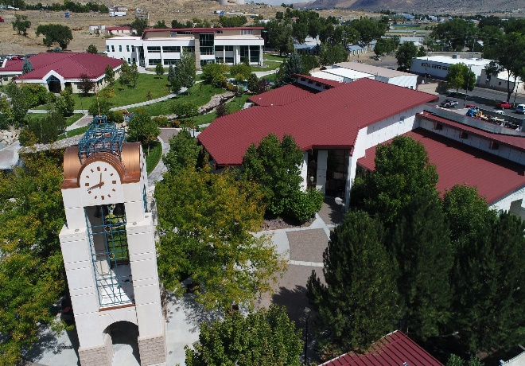

MANAGING YOUR FINANCIAL AID
It is important to stay on top of all the deadlines associated with FAFSA, required documents, and GBC's financial aid timeline. Visit Student Financial Services, located in Berg Hall of the Elko Campus, or online for more information.
FAFSA: Any student, regardless of income, who wants to be considered for federal, state, and school financial aid programs must complete the Free Application for Federal Student Aid (FAFSA). This includes grants, scholarships, work-study funds, and loans. FAFSA forms and deadlines may be found on the U.S. Department of Education’s Federal Student Aid page.

Student Aid Index (SAI):
SAI is calculated based on the data reported on your submitted FAFSA and is used by Student Financial Services to calculate eligibility for need-based financial aid. The data used includes income and assets as well as family size.

Appeal (FAFSA): If you or your family has a change in financial circumstances there are times the financial aid eligibility can be reconsidered.
- 2024-2025 Financial Aid Appeal Form

Disbursement: When the source(s) of your financial aid pays GBC the amount you were awarded toward your semester tuition and fees.
TYPES OF FINANCIAL AID
Financial aid comes in many forms, with some based on your merits, and others based on your family information and financial aid application. Learn about the different types of aid you are eligible for, and carefully review eligibility requirements and the interest rates you will be expected to pay back in addition to the amount of the loan.

Federal Loan: A loan provided by the federal government that must be repaid with interest.

- Direct Subsidized Loan: A federal loan that won’t charge you interest while you’re enrolled in school or during the six-month grace period.
- Direct Unsubsidized Loan: A federal loan in which interest starts accumulating from the date of your first loan disbursement (when you receive funds from your school).
You may qualify for loan “forgiveness,” also called “cancellation” and “discharge,” in certain situations. Visit the Federal Student Aid webpage to see if you qualify!
Private Student Loan: A loan provided by a private lender (i.e. not state- or federally funded organizations) that must be paid back with interest. They generally do not have the flexible repayment terms or borrower protections offered by federal student loans.
Grants: Grants are need-based funds awarded to students that typically do not need to be repaid. Funds are awarded based on student need and FAFSA information. Students must meet certain eligibility criteria to receive grant funds.
Scholarships: Scholarships are gifts. They do not need to be repaid. They may be offered by the state, schools, employers, individuals, private companies, nonprofits, communities, religious groups, and professional and social organizations.
Scholarships may be merit-based, requiring you to meed or exceed certain standards set by the scholarship-giver.
Scholarships may be geared toward particular groups of people (e.g., identity, background, where your parent works)
Some scholarships cover all of your college costs and some cover only a partial amount.
The most frequently awarded scholarships at GBC are the Nevada Promise Scholarship, the Governor Guinn Millennium Scholarship, and the Maintenance Training Cooperative (MTC Scholarship).
Check to see if you qualify and make sure to check out GBC’s current list of other scholarships, too!
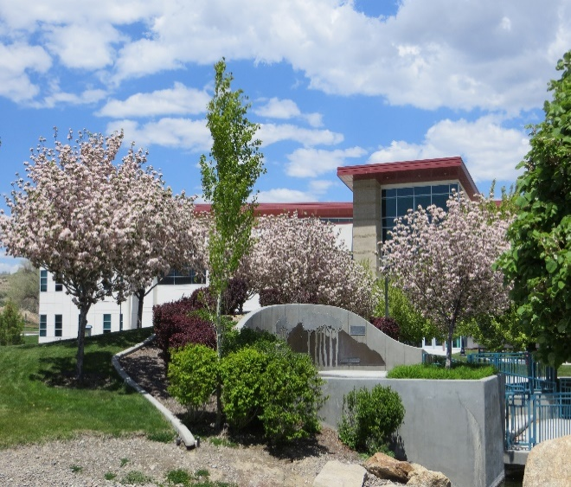
STUDENT EMPLOYMENT AT GBC
Federal Work-Study: Federal Work-study is a part-time employment program designed to help you meet your cost of attendance. The Federal Work-Study/College Work-Study (FWS/CWS) Program is a need-based student employment program. To be employed under FWS/CWS, you must:
- Apply for financial aid by filing the FAFSA
- Be enrolled in at least 6 credit hours
- Apply for a FWS/CWS job on the GBC Job Board. These will be identified as “Student Worker” jobs.
- Be offered FWS/CWS as part of your financial aid award
- Maintain a 2.0 GPA

PAYING FOR CLASSES
COSTS OF ENROLLMENT
You may not be enrolled in the same number of credit hours every semester. This can affect the cost of your tuition and fees. Make sure to discuss your plans with your academic advisor and follow up with Student Financial Services if the number of credits you are taking changes to ensure you are aware of the impact the changes may have on your financial aid awards.

- Tuition: the amount charged for academic instruction and related services.

- Fee: additional costs in addition to tuition. Fees charged may vary by degree program.

Overview of GBC Tuition and Fees
Credit hour: the unit of measurement used to indicate the amount of instructional and learning time required to achieve the student learning outcomes of an individual course.
- Each course is generally three credit hours each, with labs incurring an additional fourth unit.

Full-Time Enrollment: enrollment in 12 or more credits hours.
- This is typically four courses (4 courses x 3 credit hours each = 12 credit hours).

Part-Time Enrollment: A part-time student is a student enrolled in fewer than 12 credit hours.

Satisfactory Academic Progress: Satisfactory Academic Progress are federally mandated academic requirements that must be met by a student receiving financial aid to maintain eligibility for financial aid in the next academic year.
- Satisfactory Academic Progress Policy



Academic Sessions
- Fall Semester: Period between August and December in which 16-week courses are offered.

- Spring Semester: Period between January and May in which 16-week courses are offered.
- Mini Session: Short period offered at the beginning and midpoints of the fall and spring semester in which student can enroll in courses that cover 16 weeks of course content in 8 weeks (or less).

- Winter Session- Short period from late December to late January when student can enroll in courses that cover 16 weeks of material over the course of 5 weeks.

- Summer Session: Period between mid-June and early August in which students can enroll in courses that cover 16 weeks of material in 8 weeks or less.
For more information on when each semester or session starts, visit the GBC Academic Calendar.

Things to Keep in Mind When Enrolling Each Semester/Session:
- Tuition costs will vary based on how many credit hours you take. The more credits you take, the higher your tuition will be.
- Some forms of aid can only be applied toward fall and spring semesters. Check with financial aid to make sure your aid can be applied to the semester in which you intend to enroll.

