DID YOU MEET OR ARE YOU ON TRACK TO MEET THE CTE COLLEGE CREDIT ELEGIBILITY REQUIREMENTS:
- Earned a 3.0 GPA in the CTE core course sequence.
- Passed the state end-of-program assessment that measures technical content knowledge; and
- Passed the state Workplace Readiness assessment that measures content knowledge for employability skills.
If you have met the eligibility requirements or are on track to meet the requirements, you are ready to begin the CTE College Credit Application process.

HAVE YOU EVER COMPLETED A GBC ADMISSIONS APPLICATION (THROUGH CTE COLLEGE
CREDIT - FORMERLY TECH PREP), DUAL CREDIT OR DRIVERS’ EDUCATION?
- If you answered YES, you do not need to re-apply; you may GO to STEP 2: CTE College Credit Application.
If you do not know your college ID number, please contact the CTE College Credit office at: 775-327-2278.
- If you answered NO, continue with STEP 1: GBC Admissions Application.
The CTE College Credit Application Process links are found on the CTE College Credit webpage. Scan QR Code:


STEP 1: GBC ADMISSIONS APPLICATION
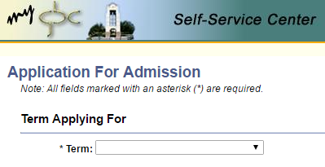
- GBC Admissions Application: Page 1
  - “Term Applying For”select term option available.

  - Social Security Number – Your social security number is not required. If you do not wish to submit your social security number, please check the box.
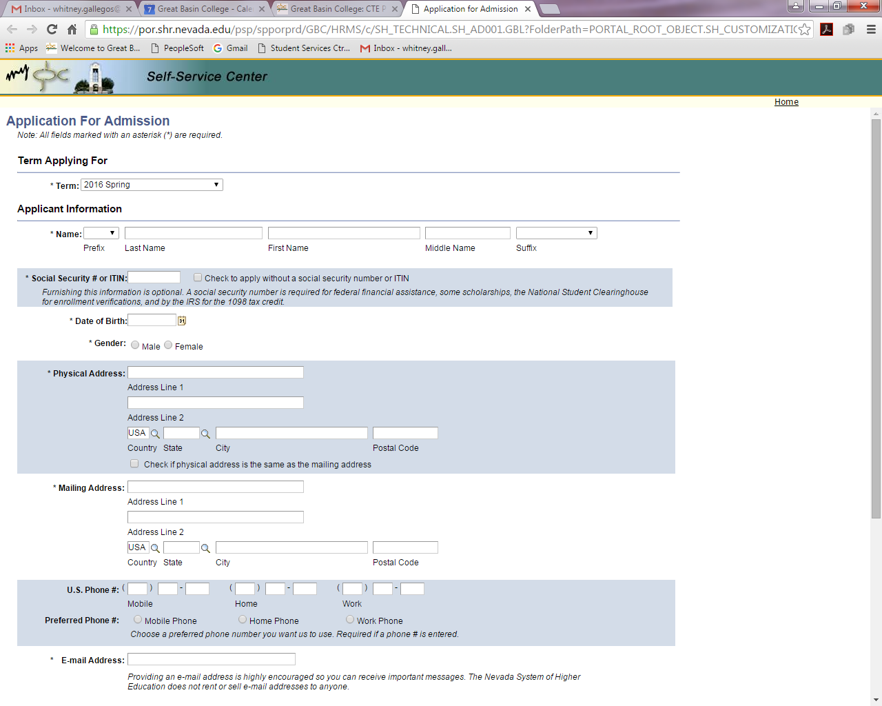

  - Student Information - All fields must be entered. You must use your full legal name. Physical address is where you live; mailing address is where you receive mail. If they are both the same, click on the box indicating that they are the same.
  - Email address is required.
  - Click CONTINUE. Verify information, then click CONTINUE again.
- GBC Admissions Application: Page 2
  - Millennium Scholar - Only select this box if you already know you will be a millennium scholar.
  - Nevada System of Higher Education Institutions - Please skip this section.
  - Former Names - This should only be filled out if you have changed your name due to adoption, marriage, etc.
  - Former Addresses - This will only need to be completed if you have moved within the past 12 months.
  - Click CONTINUE. Verify information, then click CONTINUE again.

STEP 1: GBC ADMISSIONS APPLICATION Continued…
- GBC Admissions Application: Page 3
  - Select ethnicity.
  - High School Education - Students MUST select YES, they are currently attending high school. Add anticipated graduation year (ex. 06/2016 if a senior or 06/2017 if a junior). Add High School information - you will need to select your correct high school.
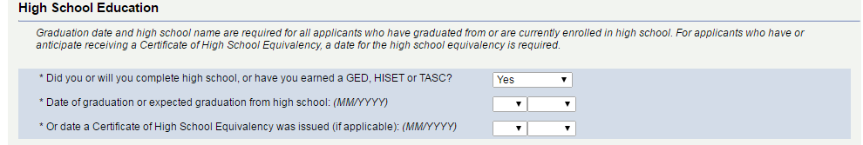

Students
MUST
mark YES

  - Citizenship - Enter USA or look up appropriate country.
  - Residency - Enter date you moved to Nevada. This can be estimated. Students born in Nevada should use their birthdate.
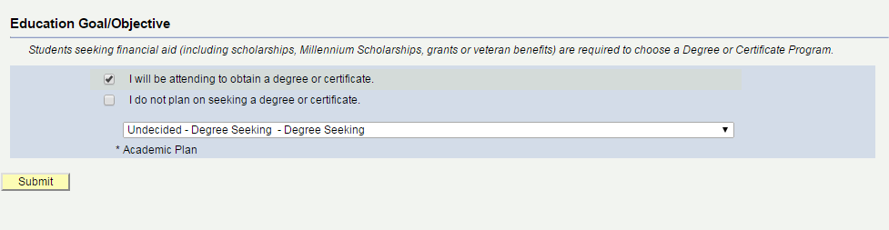
  - Educational Objective – If you want to declare your major, choose from the drop-down list. If not, select Undecided – Degree Seeking – Degree Seeking. Then click SUBMIT.

Once you have completed the GBC Admissions Application you will receive two emails. One will have your student number and one will have a temporary password. We recommend that you print these emails for your records. If you do not receive these emails within 5 days of applying, please contact the CTE College Credit Office at 775-327-2278.

When you are ready to complete Step 2: CTE College Credit Application, scan QR Code below:


STEP 2: CTE College Credit Application

1. High School Information/Program Selection
- All fields must be completed.
- Enter your high school graduation year.
- College – Select Great Basin College
- High School - Use the drop down to choose your high school
- Check the box if you would like to add an additional High School CTE program
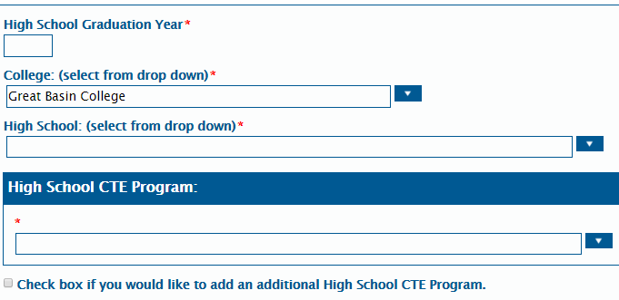

.

2. Student ID/Student Information
- NSHE ID is your college ID that was emailed to you after completing the GBC Admissions Application. You may also enter your high school ID number if you do not have an NSHE ID.
- Full legal name must be used.
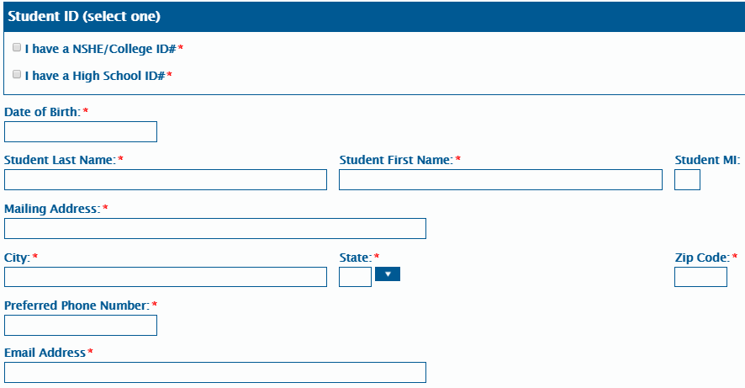
- Email - Students must have an email address

This ID number was emailed to students within 5 days
of completing the GBC Admission Application.

STEP 2: CTE College Credit Application – Signed Consent

1. Consent for High School Records Release
a. Once you have read the acknowledgements and agree with all the statements, check the box:
I/We have read the above acknowledgements and agree with all statements.
b. Student Signature - Review the directions How to sign an electronic document
c. Once you have signed the document and completed all the required criteria, click Submit Application.

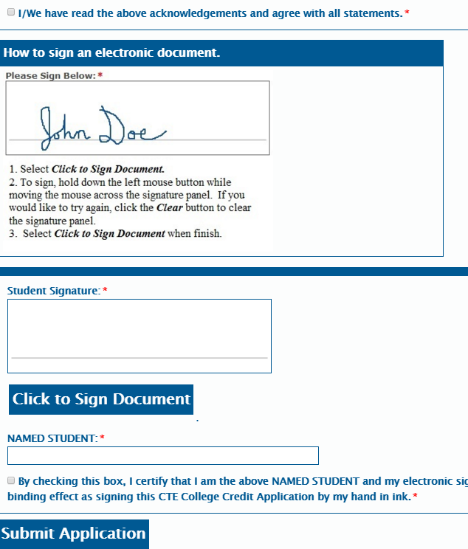
.

CTE College Credit Calendar and Information
Students must complete the 2-step application process by the deadline.

APPLICATION DEADLINE:
STUDENT LETTER: Students will receive a letter and/or email communication from CTE College Credit in August with information on how they can view their GBC Academic History, how to obtain official transcripts, the GBC admission steps, and how to access GBC Student Services Resources. All this information can also be found on the CTE College Credit website.

COLLEGE CREDIT: Credit will be recorded in the student’s GBC permanent academic records by August 31. An “S” will be awarded for the eligible GBC class(es).
www.gbc.edu/cte | 775-327-2278 |
Rev. 4/21/23

