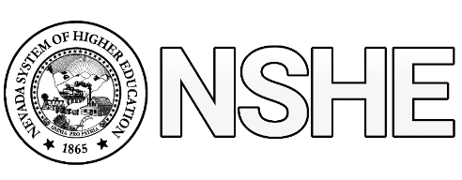

NSHE Classified Council Meeting Agenda
Date: Thursday September 26, 2019 at 9:30 a.m.
Locations: Elko –HTC 110, GBC Ely –118,
GBC Pahrump – 122, GBC Winnemucca –108, GBC Battle Mountain – BM1
BlueJeans Connection Phone Dial-in: (855) 203-2730
Meeting ID: 982 851 500

Call Meeting to Order

New Business: POSSIBLE ACTION ITEMS

- Collective Bargaining: How it Works – Adam Barrington, Washoe County AFSCME Chapter President
- Classified Council: Structure for Organizational Sustainability
  - Leadership: Chair or President, Vice Chair or President, Secretary
    - Selection Process, Length of Term, Records Repository
- Board of Regents September Meeting Statement for NSHE Classified Council: Recap / Comments
- New Award Proposal: Board of Regents Classified Employee of the Year
- Meeting Schedule – Do quarterly meetings (Thursdays at 9:30am) work for all?

Public Comment:

Next Meeting:

Adjourn

