Course Prefix, Number, and Title: NUTR121 Human Nutrition
Section Number(s): 1003
Department: Nursing
Instructor: Dorothy Callander
Academic Year: 2023-2024
Semester: Spring
Is this a GenEd class? Yes X No___

Complete and submit your assessment report electronically to your department chair. As needed, please attach supporting documents and/or a narrative description of the assessment activities. You may use as many or as few outcomes as necessary.

Class/Course Outcomes | Assessment Measures | Assessment Results | Outcome Results Analysis
In the boxes below, summarize the outcomes assessed in your class or course during the last year. If this is a GenEd class, include the appropriate GenEd objectives. | In the boxes below, summarize the methods used to assess course outcomes during the last year. Include the criterion you’ll use to judge whether or not students have achieved the expected outcome. | In the boxes below, summarize the results of your assessment activities during the last year. Include your judgement as to whether or not the criterion for student achievement has been met. | In the boxes below, please reflect on this outcome’s results and summarize how you plan to use the results to improve student learning.
Outcome #1:  What is Nutrition: Identify the six categories of nutrients and understanding the importance each plays in sustaining body processes and the effect on overall health. Identify the best dietary approach to meet nutrient needs. Be able to identify reliable nutritional information as opposed to misinformation | Assessment Measure:  Exams & quizzes  Pearson Mastering Nutrition online homework and activities  Nutrient Analysis Assignments  Mini-Nutrition Brochure assignment  Lab 4: Making Healthy Choices When Eating Out  Criterion for achievement:  Points awarded | Results:  Class grades: 5 A, 10 B, 5 C, 3 D, 5 F  (total 28).  Average score for mini nutrition brochure: 45/50 for those who did the assignment  Average score for Lab 4: 19/25 several low scores for being late or missing pieces of the assignment  Criterion Met: Yes/No  Yes | 1. Results Analysis:  Students receiving lower than a C were missing multiple assignment. Multiple reminders were sent out to individual students about missing work. The late policy was extended for the first several weeks of class, but most students did not take advantage of the opportunity to make up work for 25% credit  2. Action Plan:  Continue early outreach to students missing assignments.
Outcome #2:  Chemistry Nutrition: Understand the basics of mechanical and chemical digestion. Understand how nutrients are absorbed. Identify some common digestive disorders and learn what role they play in chronic disease. | Assessment Measure:  Exams, quizzes, Pearson Mastering Nutrition online homework and activities  Lab 3: Nutrition Related to Chronic Disease and setting SMART Goals  Criterion for achievement:  Points awarded | Results:  Average score for Lab 3: 19/25 several low scores for being late or missing pieces of the assignment  Criterion Met: Yes/No  Yes | 1. Results Analysis: Students who turned the assignments in on time did well. Students who did not turn the assignments in on time were sent reminders.  .  2. Action Plan:  Continue early outreach to students missing assignments.
Outcome #3:  Tools for Good Nutrition:  Be able to identify common nutritional deficiencies in the U.S. among various age groups and ethnic groups and treatment modalities. Utilize dietary standards and guidelines for weight management and disease prevention while promoting good health. | Assessment Measure:  Exams, quizzes, Pearson Mastering Nutrition online homework and activities  Lab 4: Making Healthy Choices When Eating Out  Nutrient Analysis Assignment Part 2  Criterion for achievement:  Points awarded | Results:  Average score for Lab 4: 19/25 several low scores for being late or missing pieces of the assignment  Average score for Nutrient Analysis part 2: 47/50  Criterion Met: Yes/No  Yes | 1. Results Analysis:  Based on reflection portion of Nutrient Analysis part 2, students showed some health & wellness improvements, and a better understanding of how to continue improvements.  2. Action Plan:  No changes
Outcome #4: (Gen Ed)  Scientific Reasoning:  a. Demonstrate an understanding of the scientific methodologies used in various disciplines | Assessment Measure:  Lab 1: Understanding the Scientific Method and Identifying Credible Nutrition Information  Criterion for achievement:  Points awarded | Results:  Average score for Lab : 21/25  Criterion Met: Yes/No  Yes | 1. Results Analysis: Students who completed this assignment did well.  2. Action Plan:  No changes
b. Effectively interpret and apply scientific principles and concepts | Assessment Measure:  Lab 2: Portion Sizes and Reading the Nutrition Facts Panel  Lab 4: Making Healthy Choices When Eating Out  Criterion for achievement:  Points awarded | Results:  Average score for Lab 2: 21/25  Average score for Lab 4: 19/25 several low scores for being late or missing pieces of the assignment  Criterion Met: Yes/No  Yes | 1. Results Analysis: Students who completed these assignments on time did well  2. Action Plan:  No changes
c. Apply scientific reasoning to the evaluation, analysis or interpretation of models and theories developed in the sciences | Assessment Measure:  Lab 4: Making Healthy Choices When Eating Out  Criterion for achievement:  Points awarded | Results:  Average score for Lab 4: 19/25 several low scores for being late or missing pieces of the assignment  Criterion Met: Yes/No  Yes | 1. Results Analysis: : Students who completed this assignment did well.  2. Action Plan:  No changes
Outcome #5: (Gen Ed)  Scientific Data Interpretation a. Effectively apply mathematical principles and quantitative methods to collect and analyze scientific data  . | Assessment Measure:  Lab 2: Portion Sizes and Reading the Nutrition Facts Panel  Criterion for achievement:  Points awarded | Results:  Average score for Lab 2: 21/25  Criterion Met: Yes/No  Yes | 1. Results Analysis: : Students who completed this assignment did well.  2. Action Plan:  No changes
b. Utilize the scientific method to arrive at informed conclusions | Assessment Measure:  Lab 4: Making Healthy Choices When Eating Out  Criterion for achievement:  Points awarded | Results:  Average score for Lab 4: 19/25 several low scores for being late or missing pieces of the assignment  Criterion Met: Yes/No  Yes | 1. Results Analysis: : Students who completed this assignment did well.  2. Action Plan:  No changes

Notes: Plan to evaluate course every spring

I have reviewed this report:

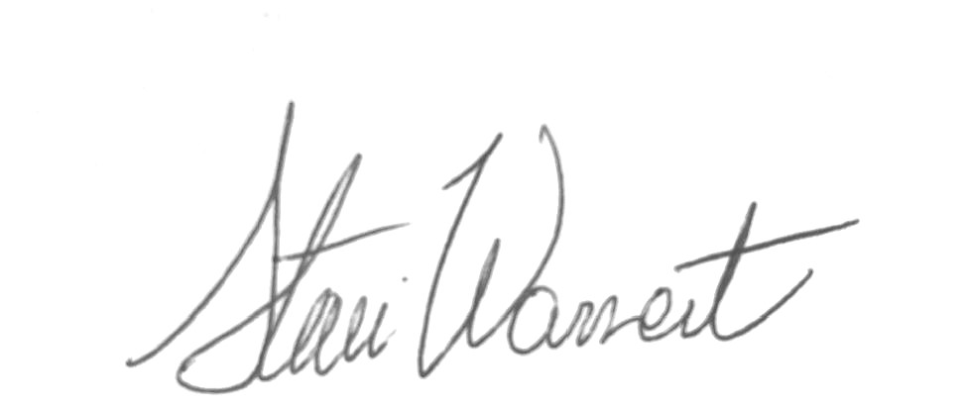
_________________________________________________ ____________________________________________________
Department Chair Dean

Date________________ Date__6-1-2024_____________

________________________________________________
Vice President of Academic Affairs and Student Services

Date_______________

