Course Prefix, Number, and Title: ENG 416C: Special Topics in English (Comics and Graphic Novels)
Section Number(s): 1001
Department: Arts and Letters
Instructor: Josh Webster
Academic Year: 2023-2024
Semester: Spring 2024
Is this a GenEd class? Yes_X__ No___

Complete and submit your assessment report electronically to your department chair. As needed, please attach supporting documents and/or a narrative description of the assessment activities. You may use as many or as few outcomes as necessary.

Class/Course Outcomes | Assessment Measures | Assessment Results | Outcome Results Analysis
In the boxes below, summarize the outcomes assessed in your class or course during the last year. If this is a GenEd class, include the appropriate GenEd objectives. | In the boxes below, summarize the methods used to assess course outcomes during the last year. Include the criterion you’ll use to judge whether or not students have achieved the expected outcome. | In the boxes below, summarize the results of your assessment activities during the last year. Include your judgement as to whether or not the criterion for student achievement has been met. | In the boxes below, please reflect on this outcome’s results and summarize how you plan to use the results to improve student learning.
Outcome #1: Students will critically analyze graphic novels and demonstrate an understanding of the medium. | Assessment Measure: Assessment of discussion/response assignments, Assessment of formal course papers.  Criterion for achievement: 80% of students completing measured assignments achieve at least 80% total points on measured assignments. | Results: 100% of students met the criteria.  Criterion Met: Yes | 1. Results Analysis: While students met the criteria, their ability to discuss art as a communicative element could use improvement.  2. Action Plan: Model the analysis of art to a greater degree.
Outcome #2: Students will explicate connections between course texts and cultural issues. | Assessment Measure: Assessment of discussion/response assignments, Assessment of formal course papers.  Criterion for achievement: 80% of students completing measured assignments achieve at least 80% total points on measured assignments. | Results: 100% of students met the criteria.  Criterion Met: Yes | 1. Results Analysis: Students are effective on this overall, though detailing the significance of a work in a larger cultural context could use improvement.  2. Action Plan: Discuss the importance of significance in literary analysis early on.
Outcome #3: Students will use interpretive frameworks to analyze graphic novels in a variety of genres. | Assessment Measure: Assessment of discussion/response assignments, Assessment of formal course papers.  Criterion for achievement: 80% of students completing measured assignments achieve at least 80% total points on measured assignments. | Results: 100% of students met the criteria.  Criterion Met: Yes | 1. Results Analysis: Overall, students did an effective job with this.  2. Action Plan: Continue as usual.
Outcome #4: Students will demonstrate their ability to synthesize complex literary analyses using course texts, interpretive frameworks and the work of other critics. | Assessment Measure: Assessment of discussion/response assignments, Assessment of formal course papers.  Criterion for achievement: 80% of students completing measured assignments achieve at least 80% total points on measured assignments. | Results: 100% of students met the criteria.  Criterion Met: Yes | 1. Results Analysis: Students could use literary sources in their writing more effectively.  2. Action Plan: Discuss the role of scholarship and criticism early in the course.

Notes: Overall, students met the outcomes for this course, though their performance could use refinement. Students seemed to struggle with effectively close reading graphic novels, particularly the art, and getting at the overall cultural and literary significance of the texts they were analyzing in some cases. I believe this will require additional modeling of these skills, as well as explicit instruction in art analysis and understanding literary and cultural significance of texts.

I have reviewed this report:

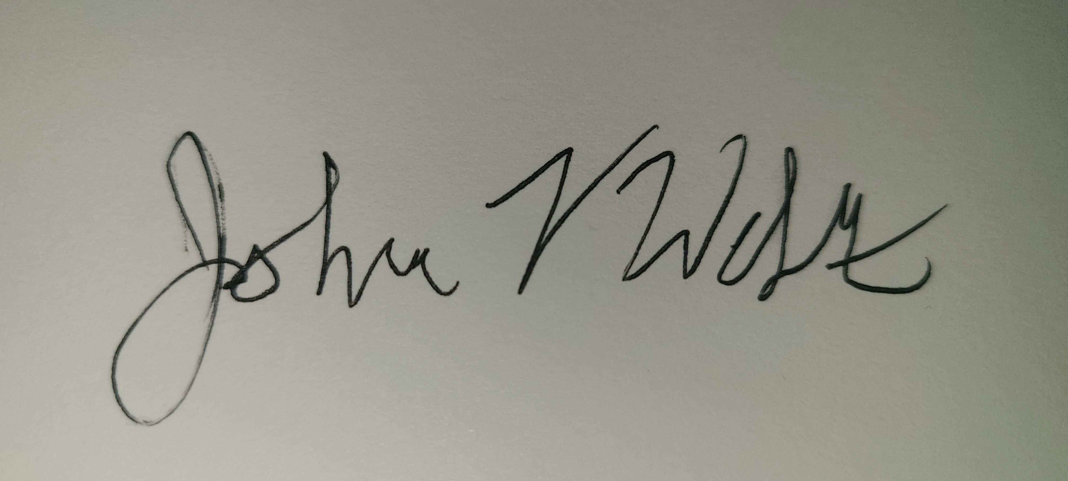

_________________________________________________ ____________________________________________________
Department Chair Dean

Date 5/23/2024 Date_______________

________________________________________________
Vice President of Academic Affairs and Student Services

Date_______________

