Course Prefix, Number, and Title: ENG 205: Introduction to Creative Writing
Section Number(s): 1001
Department: Arts and Letters
Instructor: Josh Webster
Academic Year: 2023-2024
Semester: Spring 2024
Is this a GenEd class? Yes_X__ No___

Complete and submit your assessment report electronically to your department chair. As needed, please attach supporting documents and/or a narrative description of the assessment activities. You may use as many or as few outcomes as necessary.

Class/Course Outcomes | Assessment Measures | Assessment Results | Outcome Results Analysis
In the boxes below, summarize the outcomes assessed in your class or course during the last year. If this is a GenEd class, include the appropriate GenEd objectives. | In the boxes below, summarize the methods used to assess course outcomes during the last year. Include the criterion you’ll use to judge whether or not students have achieved the expected outcome. | In the boxes below, summarize the results of your assessment activities during the last year. Include your judgement as to whether or not the criterion for student achievement has been met. | In the boxes below, please reflect on this outcome’s results and summarize how you plan to use the results to improve student learning.
Outcome #1: Students will produce fictive and poetic works of various lengths and genres.  (Fine Arts Gen. Ed. Outcome: Demonstrate the ability to engage in the creative process as it applies to the subject.) | Assessment Measure: Course projects, end of semester portfolio, weekly writing exercises.  Criterion for achievement: 70% of students completing measured assignments achieve at least 70% total points on measured assignments. | Results: 100 percent of students attempting achieved this outcome.  Criterion Met: Yes | 1. Results Analysis: The introduction of notes checks has increased student performance and understanding of course materials.  2. Action Plan: Continue current efforts.
Outcome #2: Students will demonstrate an understanding of and develop their own creative writing process.  (Fine Arts Gen. Ed. Outcome: Demonstrate the effective use and application of artistic tools and processes.) | Assessment Measure: Course projects, end of semester portfolio, weekly writing exercises, participation in writing workshops.  Criterion for achievement: 70% of students completing measured assignments achieve at least 70% total points on measured assignments. | Results: 78% of students attempting achieved this outcome.  Criterion Met: Yes | 1. Results Analysis: Notes checks have improved other results, but students fail to either complete writing workshops or complete them correctly.  2. Action Plan: Create independent workshop assignments and seek more effective tutorials for the Canvas peer review system.
Outcome #3: Students will demonstrate an understanding of fictive writing techniques including point of view, characterization, setting, narrative structure, plot development and language use.  (Fine Arts Gen. Ed. Outcome: Demonstrate proficiency in the understanding of basic fine arts concepts and language.) | Assessment Measure: Course projects, end of semester portfolio, weekly writing exercises, participation in writing workshops.  Criterion for achievement: 70% of students completing measured assignments achieve at least 70% total points on measured assignments. | Results: 78% of students attempting achieved this outcome.  Criterion Met: Yes | 1. Results Analysis: Notes checks have improved other results, but students fail to either complete writing workshops or complete them correctly.  2. Action Plan: Create independent workshop assignments and seek more effective tutorials for the Canvas peer review system.
Outcome #4: Students will demonstrate an understanding of poetic techniques including meter, verse and poetic forms.  (Fine Arts Gen. Ed. Outcome: Demonstrate proficiency in the understanding of basic fine arts concepts and language.) | Assessment Measure: Course projects, end of semester portfolio, weekly writing exercises, participation in writing workshops.  Criterion for achievement: 70% of students completing measured assignments achieve at least 70% total points on measured assignments. | Results: 78% of students attempting achieved this outcome.  Criterion Met: Yes | 1. Results Analysis: Notes checks have improved other results, but students fail to either complete writing workshops or complete them correctly.  2. Action Plan: Create independent workshop assignments and seek more effective tutorials for the Canvas peer review system.
Outcome #5: Students will learn to read fiction and poetry from the perspective of craft and provide useful criticism/feedback on the work of other writers. | Assessment Measure: Participation in writing workshops.  Criterion for achievement: 70% of students completing measured assignments achieve at least 70% total points on measured assignments. | Results: 78% of students attempting achieved this outcome.  Criterion Met: Yes | 1. Results Analysis: Students fail to either complete writing workshops or complete them correctly.  2. Action Plan: Create independent workshop assignments and seek more effective tutorials for the Canvas peer review system.
Outcome #6: Students will participate in the creative writing workshop. | Assessment Measure: Participation in writing workshops.  Criterion for achievement: 70% of students completing measured assignments achieve at least 70% total points on measured assignments. | Results: 78% of students attempting achieved this outcome.  Criterion Met: Yes | 1. Results Analysis: Students fail to either complete writing workshops or complete them correctly.  2. Action Plan: Create independent workshop assignments and seek more effective tutorials for the Canvas peer review system.

Notes: This term I implemented note checks, which require students to submit notes for the recorded lectures, as I hoped this would improve student outcomes (neglect of lectures has been an ongoing problem in the class). Student performance improved in all outcome assessments with the exception of the writing workshops. I suspect this is the result of two things: 1. The lack of an effective tutorial for using the peer review system in Canvas, which I cannot correct due to access issues and 2. The lack of an independent and obvious assignment for peer reviews (the assignment is built into the original submission, which makes it less obvious to students). To address this, I plan to work with Distance Learning to develop more effective tutorials for the system and, in the class, creating an independent peer review assignment that makes the requirements obvious to students.

I have reviewed this report:

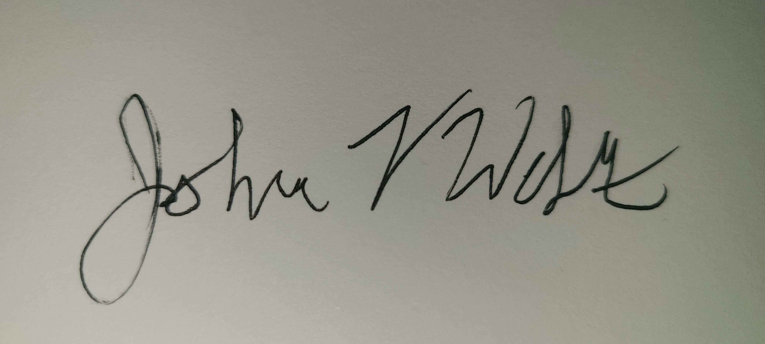

_________________________________________________ ____________________________________________________
Department Chair Dean

Date 5/23/2024 Date_______________

________________________________________________
Vice President of Academic Affairs and Student Services

Date_______________

