Course Prefix, Number, and Title: ENG 101: Composition I
Section Number(s): 1005
Department: Arts and Letters
Instructor: Josh Webster
Academic Year: 2023-2024
Semester: Fall 2023
Is this a GenEd class? Yes_X__ No___

Complete and submit your assessment report electronically to your department chair. As needed, please attach supporting documents and/or a narrative description of the assessment activities. You may use as many or as few outcomes as necessary.

Class/Course Outcomes | Assessment Measures | Assessment Results | Outcome Results Analysis
In the boxes below, summarize the outcomes assessed in your class or course during the last year. If this is a GenEd class, include the appropriate GenEd objectives. | In the boxes below, summarize the methods used to assess course outcomes during the last year. Include the criterion you’ll use to judge whether or not students have achieved the expected outcome. | In the boxes below, summarize the results of your assessment activities during the last year. Include your judgement as to whether or not the criterion for student achievement has been met. | In the boxes below, please reflect on this outcome’s results and summarize how you plan to use the results to improve student learning.
Outcome #1: Students will effectively determine their purpose and generate appropriate ideas for that purpose.  (Written Communication Gen. Ed Outcome: Effectively identify and address various audiences and contexts) | Assessment Measure: Responses to discussion assignments, Assessment of course projects, Self-evaluation, Final Portfolio  Criterion for achievement: 70% of students completing measured assignments achieve at least 70% total points on measured assignments. | Results: 91% of students attempting the measure achieved a 70% or higher.  Criterion Met: Yes | 1. Results Analysis: Implementation of note checks has increased overall student understanding, if not participation.  2. Action Plan: Continue with current efforts.
Outcome #2: Students will organize ideas into a specific rhetorical pattern relevant to their purpose in writing.  (Written Communication Gen. Ed Outcome: Utilize written genres appropriate to task) | Assessment Measure: Responses to discussion assignments, Assessment of course projects, Self-evaluation, Final Portfolio  Criterion for achievement: 70% of students completing measured assignments achieve at least 70% total points on measured assignments. | Results: 91% of students attempting the measure achieved a 70% or higher.  Criterion Met: Yes | 1. Results Analysis: Implementation of note checks has increased overall student understanding, if not participation.  2. Action Plan: Continue with current efforts.
Outcome #3: Students will use diction, point of view, and structure based on an understanding of their chosen audience.  (Written Communication Gen. Ed Outcome: Express ideas clearly and compellingly in text) | Assessment Measure: Responses to discussion assignments, Assessment of course projects, Self-evaluation, Final Portfolio  Criterion for achievement: 70% of students completing measured assignments achieve at least 70% total points on measured assignments. | Results: 91% of students attempting the measure achieved a 70% or higher.  Criterion Met: Yes | 1. Results Analysis: Implementation of note checks has increased overall student understanding, if not participation.  2. Action Plan: Continue with current efforts.
Outcome #4: Students will demonstrate their understanding of the writing process and apply the fundamentals of revision. | Assessment Measure: Responses to discussion assignments, Peer review responses, Self-evaluation, Final Portfolio  Criterion for achievement: 70% of students completing measured assignments achieve at least 70% total points on measured assignments. | Results: 91% of students attempting the measure achieved a 70% or higher.  Criterion Met: Yes | 1. Results Analysis: Implementation of note checks has increased overall student understanding, if not participation.  2. Action Plan: Continue with current efforts.
Outcome #5: Students will develop and demonstrate critical reading and responding skills in regard to their own and others’ writing. | Assessment Measure: Responses to discussion assignments, Peer review responses, Self-Evaluation  Criterion for achievement: 70% of students completing measured assignments achieve at least 70% total points on measured assignments. | Results: 82% of students attempting the measure achieved 70% or higher.  Criterion Met: Yes | 1. Results Analysis: Peer review responses still lag, along with self-evaluation performance/completion.  2. Action Plan: Seek new tutorials for peer review system; Canvas difficulty leads to significant error. Increase point value for self-evaluation.
Outcome #6: Students will articulate their understanding of writing situations and writing concepts. | Assessment Measure: Responses to discussion assignments, Self-Evaluation  Criterion for achievement: 70% of students completing measured assignments achieve at least 70% total points on measured assignments. | Results: 86% of students attempting the measure achieved 70% or higher.  Criterion Met: Yes | 1. Results Analysis: Self-evaluation completion/successful performance is lower than I would like.  2. Action Plan: Increase class instruction on self-evaluation, implement reflection activity on a more consistent basis, increase point value for self-evaluation.

Notes: This year, I implemented a note check requirement, which requires students to submit their notes on recorded lectures. As I hoped, this has improved the performance of students in the course and significantly reduced errors on assignments (not watching lectures was a consistent problem in prior semesters). Problems with peer review completion remain, due, I believe in part, to the lack of specific and clear tutorials on how the peer review system works, which I can’t produce as an instructor due to lack of access. I’ve asked Distance Learning for a more effective tutorial, but nothing has been produced by Canvas or in-house. Another issue is the performance on self-evaluations, which I intend to address by increasing reflection activities earlier in the course as well as increasing the point value of the self-evaluation assignment.

I have reviewed this report:

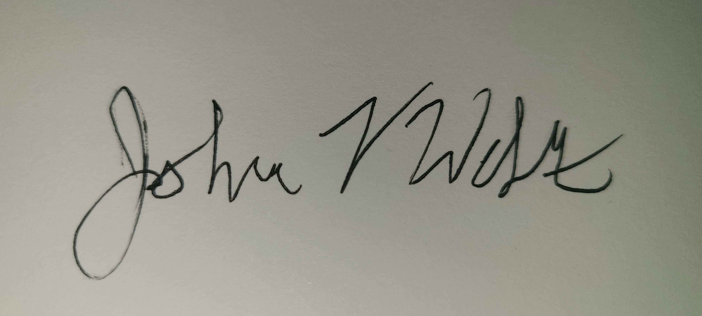
_________________________________________________ ____________________________________________________
Department Chair Dean

Date: 5/23/2024 Date_______________

________________________________________________
Vice President of Academic Affairs and Student Services

Date_______________

