Course Prefix, Number, and Title: BIOL 190 - Introduction to Cell and Molecular Biology
Academic Year: Spring 2024
Department: Biology Section Number(s): BIOL 2242 BIO 190 - Lectures (1001)
Instructor: Dr Rita Pujari Is this a GenEd class? No

Course description- Structure and function of cells. Major molecules of life; composition and physiology of cellular organelles; cell metabolism, reproduction, motility, and gene function of both plant and animal cells. Required for biology majors. Concurrent enrollment in a corresponding lab section is re- quired for this course.

Complete and submit your assessment report electronically to your department chair. As needed, please attach supporting documents and/or a narrative description of the assessment activities. You may use as many or as few outcomes as necessary.

Class/Course Outcomes | Assessment Measures | Assessment Results | Any Changes Made as a Result of Assessment
In the boxes below, summarize the outcomes assessed in your class or course during the last year. If this is a GenEd class, include the appropriate GenEd objectives. | In the boxes below, summarize the methods used to assess course outcomes during the last year. Include the criterion you’ll use to judge whether or not students have achieved the expected outcome. | In the boxes below, summarize the results of your assessment activities during the last year. Include your judgement as to whether or not the criterion for student achievement has been met. | In the boxes below, summarize how you plan to use the results to improve student learning.
Outcome #1: Molecules of Life Solve problems involving the identification and functions of the 4 classes of biologically relevant carbon compounds. | Assessment Measure: Lecture exam, quizzes, Lab material.  Criterion for achievement: 62% or more students receive 70% or higher on the assessment tool(s), and/or 65% or more students earn a 65% or higher laboratory score, and/or 70% or more students earn a 70% on course presentations. | Results:  Exam – 1 – Chapters 1 & 2 - Total score – 50 points  Average score – 56%  High -88%  Low-24%  SD- 8.15  Average time – 46.14 minutes/ 90 minutes  70% of 50 points – 35 points  7/28 - 25% students (criteria 62% or more students receive 70% or higher on the assessment tool(s)) | Criteria not met.  Bio 190 is a difficult class, and first exam is always challenging to the students.  Plans to improve:  - Decrease the number of chapters for the Exams from two to one.  - Upload recorded lectures for future reference to the students.  - Provide 4 x 6 Inches Index card to help in recalling of the information.  - Encourage students to contact tutors and complete their online assignments before taking the exams on respective chapters.  - Encourage students to use dynamic study module, gap filler modules & gap filler modules.  - Give students extra credit assignments so that they get the gist of the chapters and learn to arrange the information in the flow charts.
Outcome #2.  Evolution/Natural Selection Describe how natural selection leads to evolution, and how this process is tested with the tools of quantitative genetics | Assessment Measure: Lecture exam, quizzes, online homework.  Criterion for achievement: 62% or more students receive 70% or higher on the assessment tool(s), and/or 65% or more students earn a 65% or higher laboratory score, and/or 70% or more students earn a 70% on course presentations. | Exam – 2 - Chapter 3 & 4 – 50 points  Average score – 58%  High -98%  Low- 16%  SD- 10.7  Average time –59.43minutes/ 120 minutes.  70% of 50 – 35 points  11/25 – 44% (62% or more students receive 70% or higher on the assessment tool(s)) | Criteria not met but slight improvement from 25% to 44% in the students receiving 62% or more students receive 70% or higher on the assessment tool.  Did not use Index card for this exam but students were given an extra credit assignment on Chapter 3 to draw the flow chart of protein structure.
Outcome #3: Genetics Apply concepts of transmission and molecular genetics.  . | Assessment Measure: Lecture exam, quizzes, online homework.  Criterion for achievement: 62% or more students receive 70% or higher on the assessment tool(s), and/or 65% or more students earn a 65% or higher laboratory score, and/or 70% or more students earn a 70% on course presentations. | Exam -3 – Chapters 5 & 6 – 50 points  Average score –58 %  High -90%  Low- 16%  SD- 10.7  Average time –59.30 minutes/ 120 minutes.  11/25 – 44% (62% or more students receive 70% or higher on the assessment tool(s)) | Criteria not met. The percentage remained the same.  Students were allowed to use 4 x 6 Inches Index cards written on both the sides for Exam -3.
Outcome #4: Cellular Metabolism Describe common biochemical pathways (including glycolysis, Krebs cycle, chemiosmosis, fermentation and photosynthesis) and solve problems involving integrated cellular metabolism. | Assessment Measure: Lecture exam, quizzes, online homework.  Criterion for achievement: 62% or more students receive 70% or higher on the assessment tool(s), and/or 65% or more students earn a 65% or higher laboratory score, and/or 70% or more students earn a 70% on course presentations. | Results:  Exam – 5 – chapter 9 - Total score – 40 points  Average score – 66%  High -88%  Low-28%  SD- 6.74  Average time – 53.13 minutes/ 120 minutes  70% of 40 points – 28 points  13/23 – 56.52% students (criteria 62% or more students receive 70% or higher on the assessment tool(s))  Quiz- 7 – Chapter 7 part 1- slides 1- 52- 10 points  Average score – 77%  High -100%  Low-0%  SD- 2.7  Average time – 9.49minutes/ 30 minutes  70% of 10 points – 7 points  18/26 – 69.23% students (criteria 62% or more students receive 70% or higher on the assessment tool(s))  Quiz -10 – Chapter 9 – Respiration – 10 points  Average score – 71%  High -100%  Low-10%  SD- 2.7  Average time – 14.48 minutes/ 60 minutes  70% of 10 points – 7 points  14/22 – 63.63% students (criteria 62% or more students receive 70% or higher on the assessment tool(s))  Extra credit assignment- 3- Chapter 9 – 10 points  10/29 – 100% score – 29% student in the class received full points.  11/29- 0% score – 37% of the students -No submission – students did not bother to submit the assignment.  8/29- less than 70% score- Incomplete submission even after explaining on how to do the assignment. Recorded lectures were available to the students where I explained my expectations on the assignment. | Criteria not met.  After implementing the above plans there was a slight improvement from 44 % to 56.52%.  I split the chapters into two parts to improve quiz scores, but the results showed little change. In Quiz-7 (part 1), 69.23% of students met the criteria, while in Quiz-10 (Chapter 9), only 63.63% did. This suggests that splitting the chapters might not be the most effective strategy for boosting student performances.
TOTAL- students  Grades (approximate)  - A - 3  - B- 12  -C - 6  -D - 0  - F-8  Criteria met – 72.41% of the students received 70% or higher on the assessment tool(s), | The steps taken by me to resolve issues or problems in learning and understanding has been addressed below in a tabular form after the recommendations.  Strong Recommendations for BIO 190 class:  - Students should take BIO 100 and CHEM 100 or test into these classes before enrolling in BIO 190 class.  - If above recommendation is not possible then student should make use of all resources made available to them by the faculty.  - Student should allocate enough study time based on their initial preparedness.  - Student should not take too many classes along with BIO 190 class. One additional class (some 100 level) should be recommended to be taken along BIO 190.  - Working students with families should be advised to take only BIO 190 in a semester.  - BIO 190 lecture and lab portions should be taught by the same faculty.

 | Problems | Steps taken to Improve BIO 190 scores in lecture Exam | Results
1 | Difficulty in understanding the material taught in the class | Dedicated tutor for BIO 190 class. Contact information shared on the syllabus and in the introductory lecture. | 3 students out of 45 students in the class approached tutor for help in the lecture portion of BIO 190
2 | Students do not do well on the quizzes. | Split the chapter into two parts for the quiz. | Slight improvement in the scores.
3 | Students do not do well on the exams. | Changed the number of chapters they are tested on from 3 to 2 and then to 1. | Not much improvement.
4 | To fill in the learning gaps or revisit the basic concepts in Chemistry. smaller formative assessments tools were incorporated. | Introduced Gap Fillers from Pearson publishers to understand basic chemistry concepts like Acid, bases, chemical bonding, chemistry of Atoms & properties of water.  If students identified where they were students struggling the most. This allowed them to address those gaps before the actual quiz or exams. | Only 2 out of 45 students made use of Gap fillers.  Students don’t like to do any assignment which does not have points.  Some of the students fail to see the importance of such learning tools and they would rather struggle in the class than take benefits of these tools to improve their gaps in high school learning.  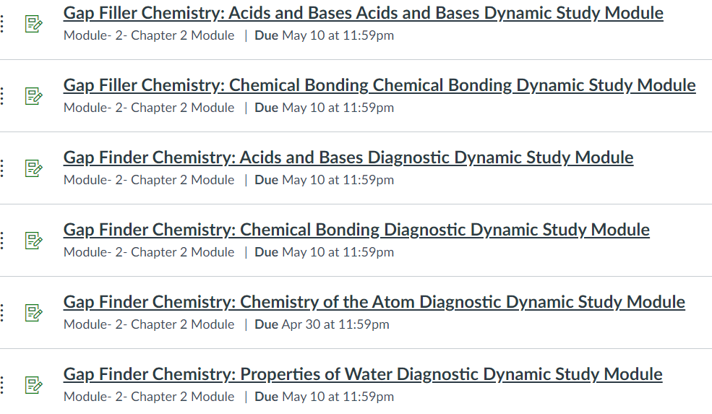
5 | Difficult to read chapters from textbook before the testing. | Introduced Video & animation in online learning Pearson’s platform so that it helps students who are visual learners.
6 | Difficult to read chapters from textbook before the testing. | To make sure all the concepts are understood before testing Dynamic Study modules form Pearson for every chapter was made available to the students and they were conveniently placed on the webcampus easily available under the chapter modules. | 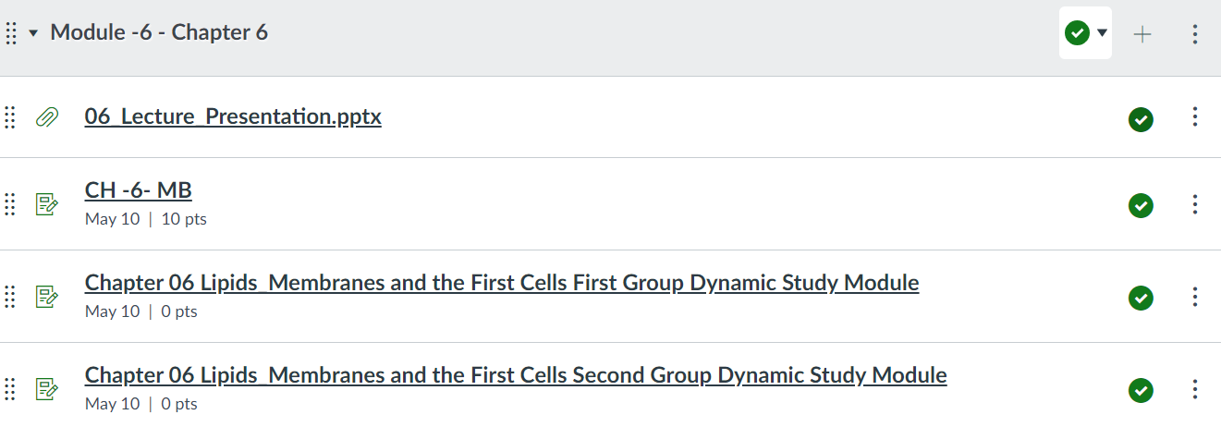
7 | Problems with Time management and other study skills. | Study skills in reading and taking notes, strength your test taking, studying vs learning, time management, how to use resources on Pearson. | On random selection of one of the study skill resources I found that only 13 out of the 45 students enrolled in the class made use of it.  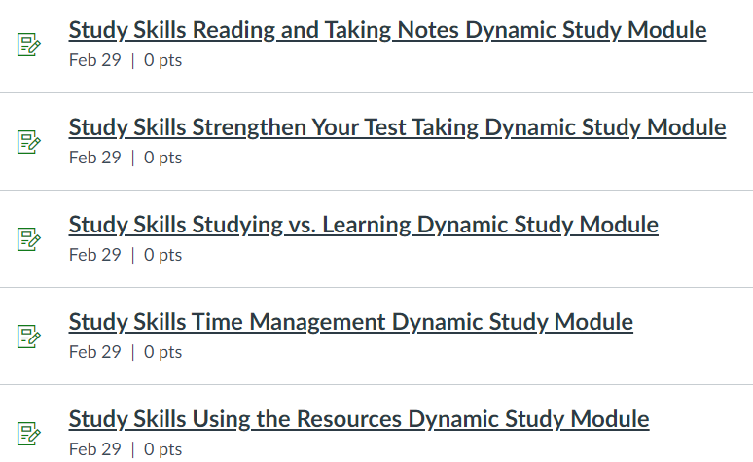
8 | Time allocated for completion of quizzes and exams | most of the quizzes and exams were completed within 1/3rd of 1/4th of the time allocated. | Students did not use time to read and think before answering Multiple choice questions.
9 | Difficulty in understanding the language of the publisher’s multiple-choice question. | Changed the Exam pattern. Introduced Essay questions based on the material covered the class. | Not much changes seen.
10 | Difficulty in memorizing the material covered in the chapter. | Allowed students to use 4 x 6 Inches Index card. | Students did not make use of the Index card to jog their memory. Some of the essay questions they scored 100% and on some they got 0%.  Student used Index card as a cheat / copying material rather than using it as a sheet to recollect information taught in the class.
11 | Difficulty in understanding overall view of the chapter. | Created assignments asking students to draw Flow charts and diagrams from the textbook. | Many students did the assignment for scoring points rather than for learning and understanding the basic concepts.
12 | Low scores on Exams | Instead of curving the scores I gave them opportunity to learn by giving extra credit point assignments. | Only 29% of the students submitted the extra credit for 10 points.
13 | Students complain of too much material is covered in class. | Try to spend more time then needed to explain concepts. | I cannot cover all the chapters listed on the syllabus.

Notes:

I have reviewed this report:

_________________________________________________ ____________________________________________________
Department Chair Dean

Date________________ Date_______________

________________________________________________
Vice President of Academic Affairs and Student Services

Date_______________

